Michael Martin

M5A1 Programming Assignment

First, here is my screenshot. Everything worked as planned. Documentation and additional comments below.

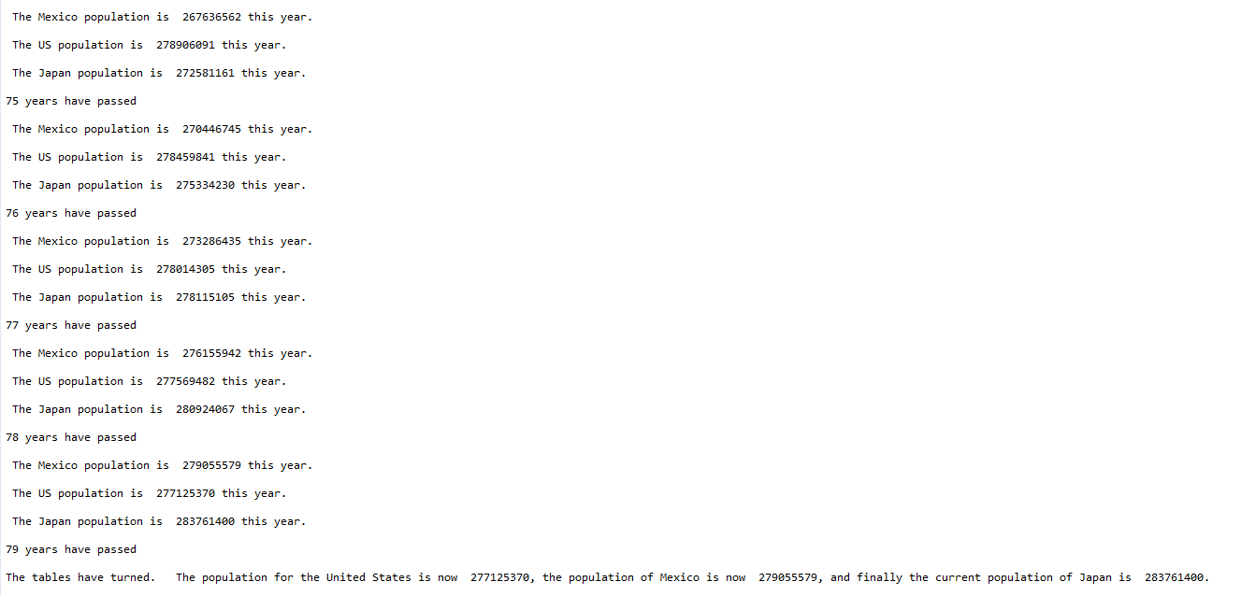

This was a challenging assignment for me. I hope this is what you intended for us to do with the usage of the while loops and the for loops. I originally created this program with a do-while loop but then refactored it with a while when I was sure it would run at least once without it.

**populationFor**: I created multiple variables that would be used for these methods. Getting the methods to perform the calculations just right took me longer than I would like to admit. I separated each multiplier (rate of growth or decline) by country and gave them their own variable so that we can easily plug them in again later to perform another simulation. I did the same with the starting populations for each country, ensuring that we can easily perform the simulation again by adding in new values, or copy-pasting the methods again for additional countries as desired.

Finally, all I needed to do was create the test method to run each of these methods in sequence as a rotation. This took me a long time to come to a conclusion about. Originally I was simulating them by running the methods from the while loop, which was running each method 100 times each (which was what I was counting) because I gave each individual country method a number of years to perform the simulation.

The test loop definitely fixed this. The if-statement breaks the loop as soon as both Mexico and Japan surpass the population of the United States. As you can see, each time the test loop runs, each of the methods print their statement indicating their current populations. The test method itself prints which year it is currently testing. The while loop’s main method prints the overall results once the test method’s if-statement detects the break conditions.

I gained a lot from this assignment. Thank you.